***Hudson Furnishing***

*User Guide*

|  |  |  |
| --- | --- | --- |
| **Supervisor** | SIR SALMAN | |
| **Batch** | 2206f | |
| **Group** | Hudson Furnishing | |
| **Serial No.** | **Enrollment Number** | **Students Name** |
| **1** | **1386760** | SAMAD |
| **­­­­­­­­2** | **1386957** | HASSAN |
| **3** | **1396147** | MASHKOOR |
| **4** | **1387224** | HASNAIN |

**USER GUIDE**

**“HUDSON FURNISHING”** This website is basically based on all type of furniture. If you are looking for best furniture for home or office, so just this website made for you.

1. **Top Layout**

This is the Top of the page.

* First user sees our Business logo or name
* User can know about the website by clicking on about us button.
* User can get address and contact info by clicking on contact us button.
* 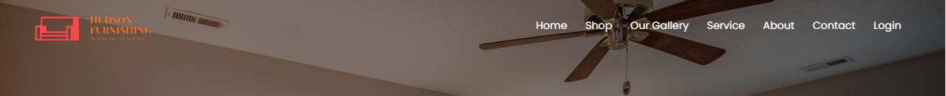User can get knowledge about services that what we are providing to our customers by clicking on service button.

1. **Home Page**

* 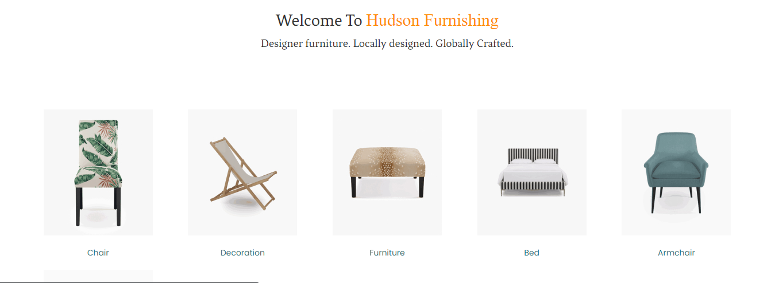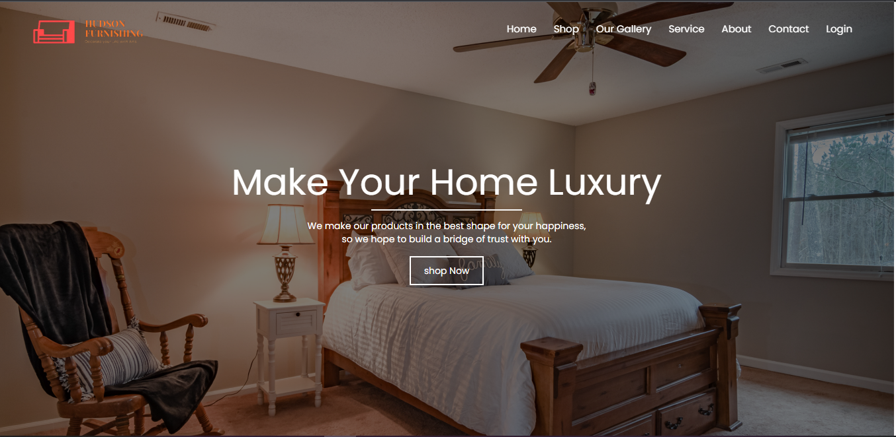 This page contains our special furniture and their details.

1. **Shop Page**

* 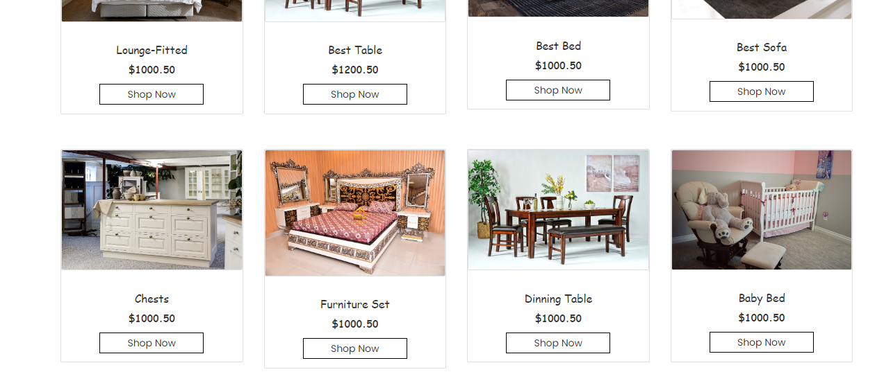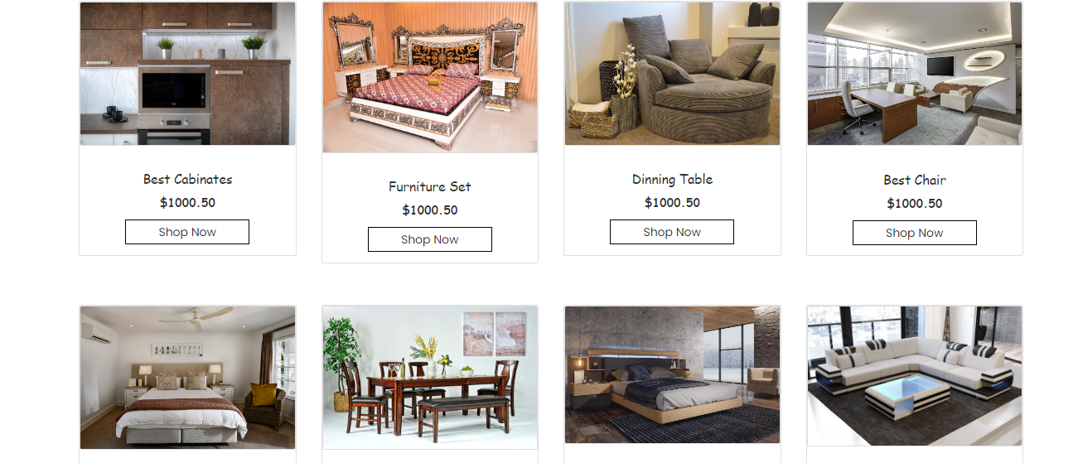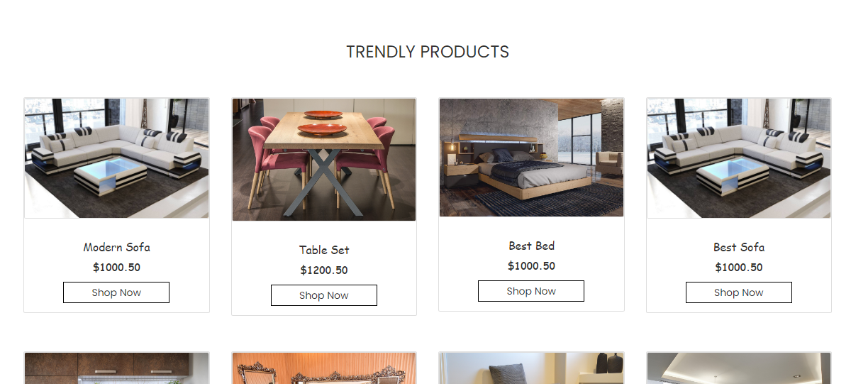 In this page user can easily choose and grab their favorite furniture.

1. **Contact Us Page**

* In this page user can get in touch with us.
* They can leave their comments.
* 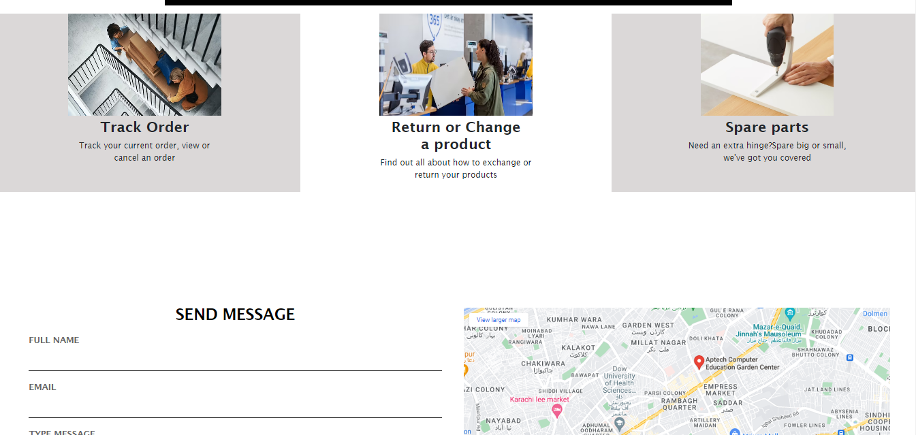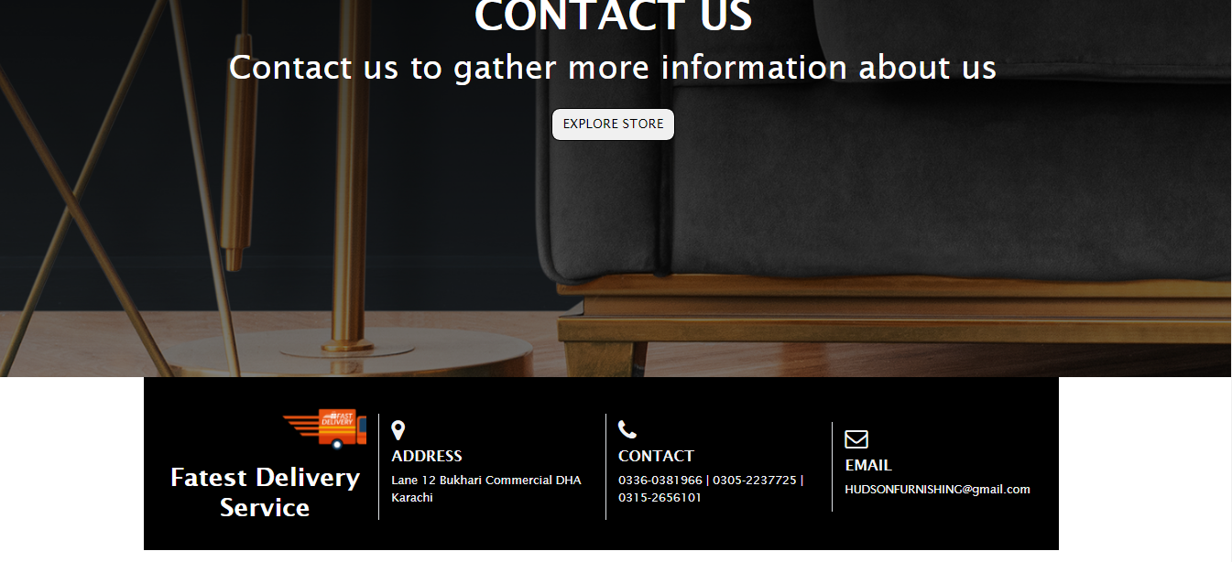They can see our shop location.

1. **About Us Page**

* 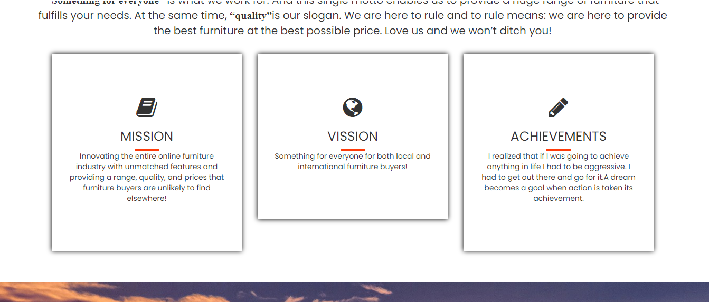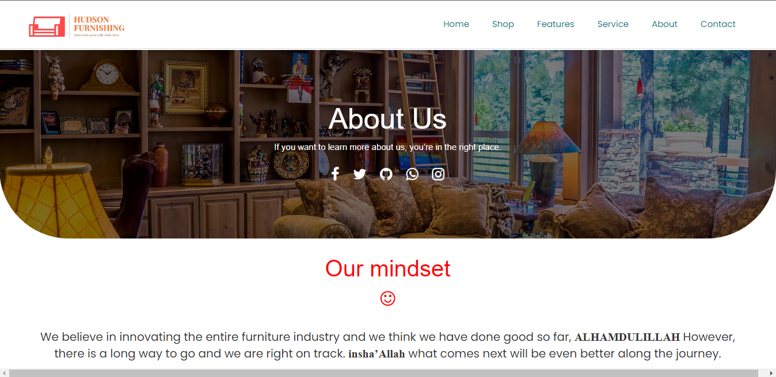This page has some information about our shop.

1. **Service Page**

* 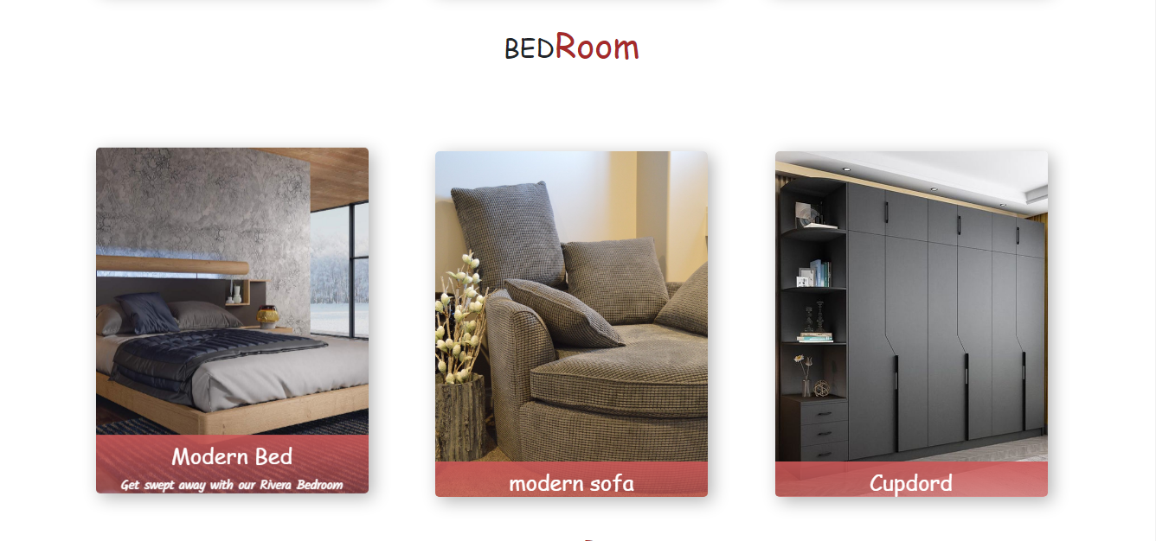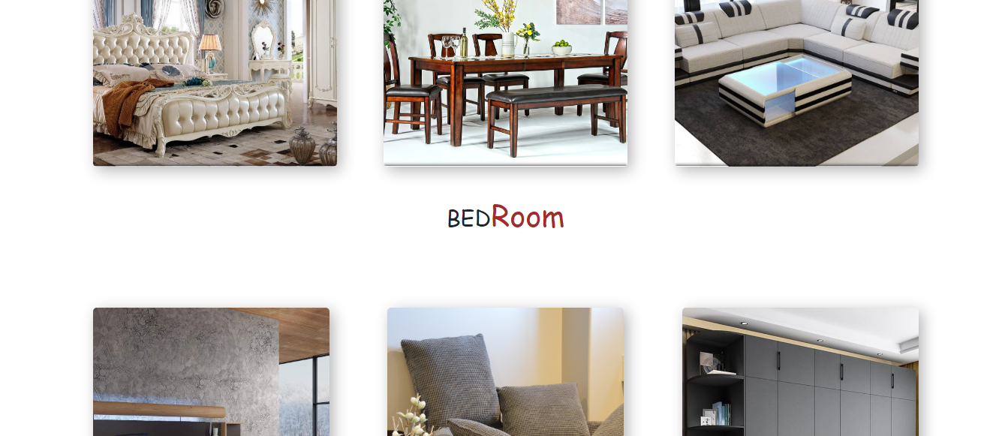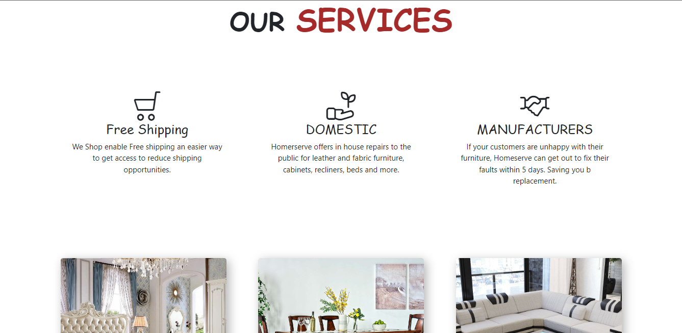In this page user can get to know about what services we are providing to our customers.

1. **Sign Up Page**

* 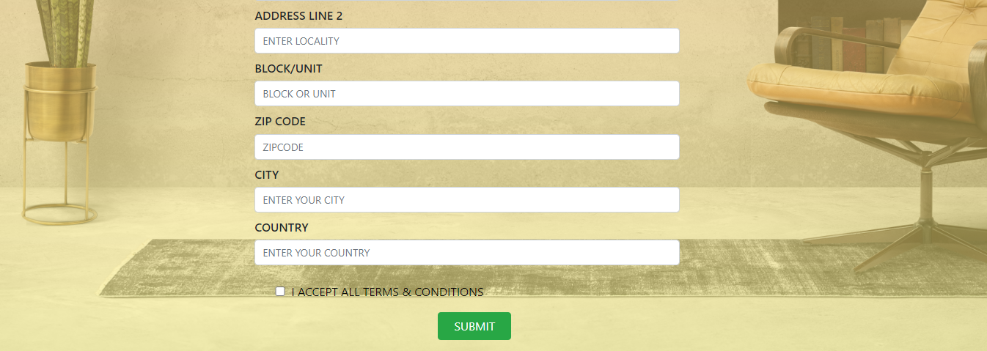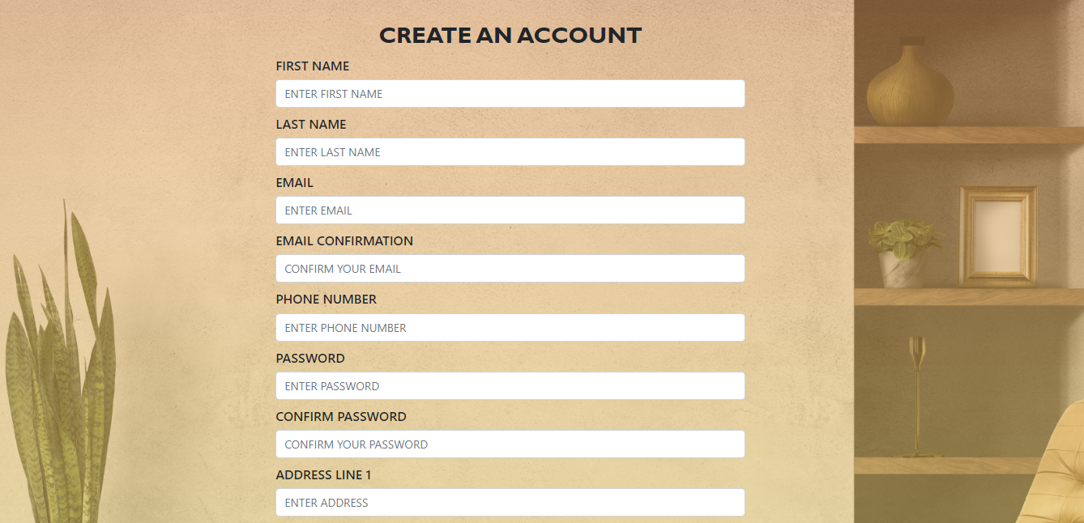 In this page new user create his/her account on our website and fill the form correctly.

1. **Login Page**

* 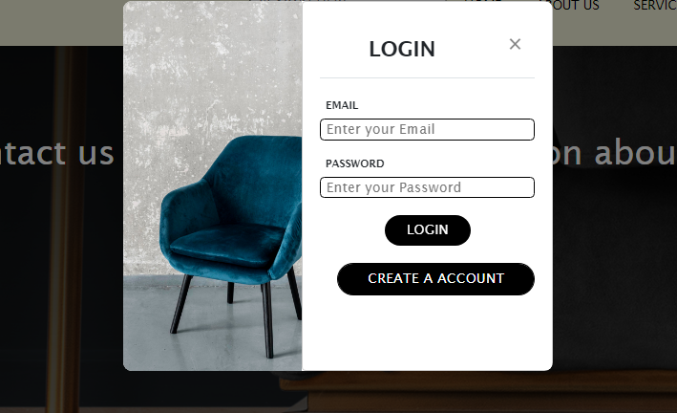Here old customer will come and login their account to purchase furniture.

1. **Bottom Page**

* It has logo of our business.
* It has some links like our gallery, shipping, payment options etc.
* 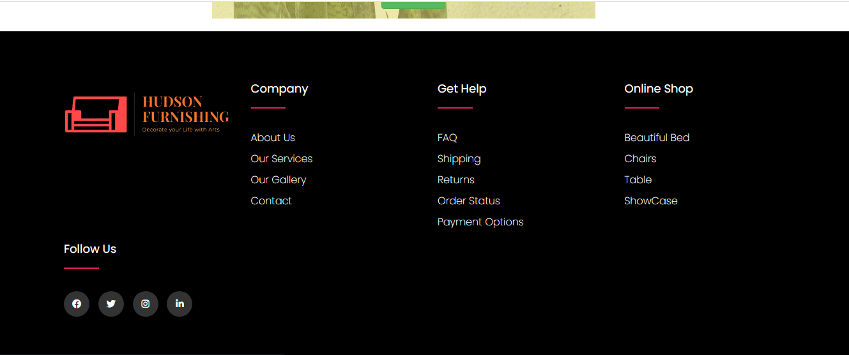It also has our Social media pages links like Facebook, Instagram etc.

**THANKYOU FOR READING THE DOCUMENTATION**